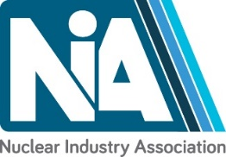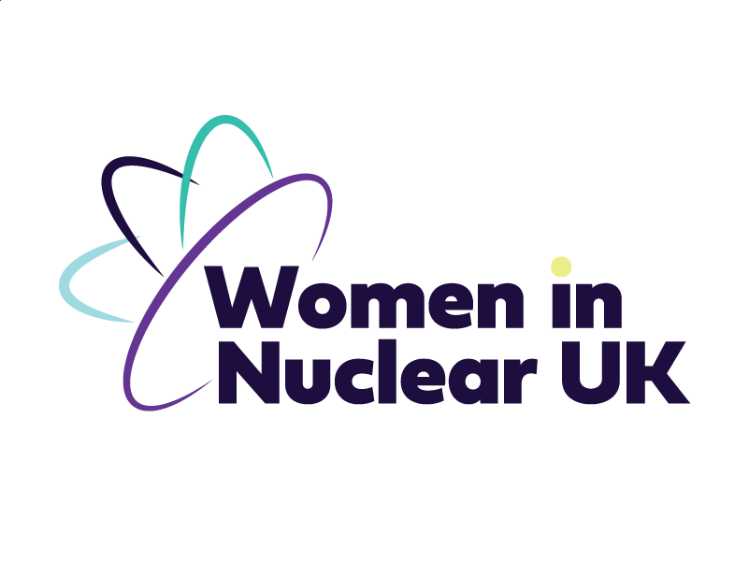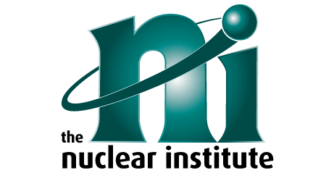
Thursday 29 September 2022
Nuclear in the Midlands
Enterprise centre, Derby
12:00 – 12:45
Lunch and registration
12:45 – 13:00
Welcome
Evan Bolle-Jones, Nuclear Institute
13:00 – 14:00
Panel session on ‘Manufacturing in the Midlands’ chaired by Michael Cartwright, Frazer Nash Consultancy
- Nuclear AMRC, Kevin Shepherd
- Forgemasters, Martin Kearney
- Ansaldo nuclear, Alan Bevan

14:00 – 14:30
Panel Session on "Nuclear Skills" – chaired by Dr Louise Pigden
– University of Derby, Robin Webber-Jones
– Rolls-Royce Submarines Ltd, Catherine Harvey
– National College for Nuclear, Chris Nattress
– Derby City Council, Tim Bagshaw
– Nuclear AMRC, Sean Eley

14:30 – 15:00
Coffee break

15:00– 16:00
Panel session on "Opportunities in the Midlands" chaired by Andrew Storer, Nuclear AMRC
- Rolls-Royce SMR, Rachel Bennet
- Rolls-Royce Submarines Ltd, Gary Jones
- UKAEA, Chris Peters

16:00 – 16:15
Wrap up
Concetta Cantone, Women in Nuclear

16:15 – 17.30
Drinks reception

