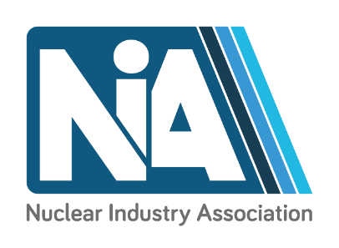

Decommisiosning & Existing Generation Group meeting
Products & Technology
22 September
Engine Rooms, Birchwood
Agenda
Registration and coffee | 09:00– 09:30
Welcome  Connor Deehan, Chair - NIA Decommissioning and Existing Generation Group | 09:30 – 09:45
Creative Thinking on Major Projects  Ian Parkinson, Morgan Sindall | 09:45 – 10:05
Technologies…  Adapting Technology Blocks  Jas Singh  Radiometric Physicist & Business Development Manager  Mirion Technologies IST Limited  Virtual Reality for Radiological Protection Training  Gary Box  Radiation Protection Adviser  CERAP UK  First of a kind deployments in harsh environments  Mark Sharpe  Sales Director  CREATEC  Crane Solutions for Nuclear and Decommissioning  Mark Bidwell  Regional Sales Manager Nuclear Equipment  Konecranes Nuclear Equipment & Services, LLC  Skera - Adapting gem cutting technology to deliver a new remotely deployable size reduction system for Sellafield.  Jim Hill  Eadon Consulting  CCTV in decommissioning and existing generation  Peter Gregory  Business Development Director for Europe  ISEC Monitoring Systems AB | 10:05 – 11.20
Break | 11:20 – 11:50
Challenges in adopting technology  Deploying robotics and autonomous systems in extreme environments  Rav Chunilal  Sellafield  Sellafield’s biggest construction project reaping benefits of 4D modelling  Dan Ashton and Olivia Peel, The Programme and Project Partners (PPP) at Sellafield  Reactor Segmentation and Offsite Transport of Waste  Gareth Thomas  Holtec Britain  AMCAM – From Concept to Product  David Kenwright,  Physicist  Cavendish Nuclear | 11:50 – 12:50
Lunch | 12:50 – 14:00
Supply Chain Development and F4N  Nigel Goodrich  F4N Industrial Advisor  Nuclear AMRC | 14:00 – 14:15
How technology will help with our partnership’s ambitions  John Griffin  PMO Director  Programme and Project Partners (PPP) at Sellafield | 14:15 – 14:30
Nuclear industry opportunities in South Korea  Mr Tim Yeo  Honorary Invest Korea Promotion Ambassador  KOTRA | 14:30 – 14:35
Business opportunities in Decommissioning and Existing Generation  Mr Hyungi Cha  Senior Manager  Korea Hydro & Nuclear Power Co., Ltd. (KHNP) | 14:35 – 14:50
Korea’s Investment Environment and Incentives  Ms Hyeon Kyung Nam  KOTRA | 14:50 15:00
Wrap up and close | 15:00
Thanks to our sponsors 